“Creating Inclusive Environments for Jewish Students:
Strategies for Supporting Jewish Students and
Addressing Antisemitism on Campus”
Presented by: Edina Oestreicher, Executive Director,
UConn Hillel- The Center for Jewish Student Life
Learn more about the diversity and needs of, and challenges facing,
today’s Jewish college students.
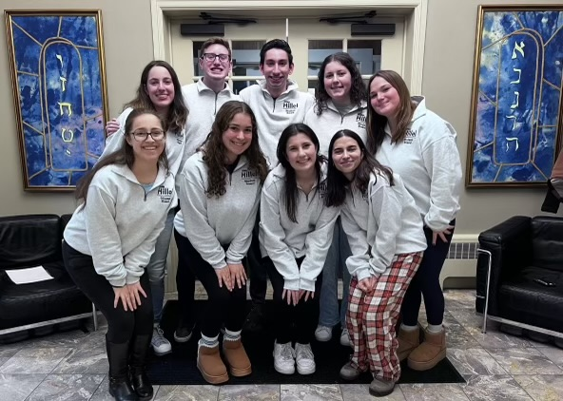
Please join us for one of two sessions;
Friday, November 7, 2025, 12:00 PM-1:15 PM
Join link:
https://uconn-cmr.webex.com/uconn-cmr/j.php?MTID=m66b187e768069ca0008d452616ac4204
Webinar number: 2866 580 3400
OR
Monday, November 10, 2025, 1:00 PM - 2:15 PM
Join link:
https://uconn-cmr.webex.com/uconn-cmr/j.php?MTID=m7478cf6a2c62dfd4934e9fa20d8a2c7d
Webinar number: 2631 812 7723

